

# Web Programming End-Of-Term Project

COM329

## Professor: Alparslan Horasan

Prepared by:

Abdulmohaimin Bashir (B2205.010021)

Muhammad Bilal (B2105.010028)

Nusaibah Mekkaoui (B2205.010015)

# Overview

This document details the purpose and the functionalities of the program.

The program was designed as an Art Gallery Management System used by the gallery’s employees to manage their featured artists, guests, and employee information. The employees will be able to login, and create a new password upon forgetting their current one, as well as add, read, update and delete said information. The project code generates a MySQL database where the information of the art gallery is managed and then stored on WampServer.

1. About the Program

The program comprises the following pages.

* Authentication
  1. Login Page
  2. Forgot Password Page
  3. Verification Code Page
  4. Landing/Home Page
* Artist

1. Artist Table
2. New Artist
3. View Artist
4. Update Artist

* Guest

1. Guest Table
2. New Guest
3. View Guest
4. Update Guest

* Employee

1. Employee Confirmation
2. Employee Table
3. New Employee
4. View Employee
5. Update Employee
6. Creating The Database

As a first-time user, they are required to add the product’s unzipped folder to their server’s folder. Then user will then start up WampServer and create a database and in MySQL by providing the proper URL in the browser’s address bar (<http://localhost/ArtGallery/DBInitialisation/createDB.php>). After the successful creation of the database, the following message will be displayed on the browser:



After creating the database, the user will have to import the file ‘art_gallery.sql’ into phpMyAdmin by going clicking on WampServer Icon>PhpMyAdmin>PhpMyAdmin>art_gallery database>Import>Choose File...>Import. The database tables will be shown once the user has refreshed the page.

The user can alternatively create the artist, guest and employee tables inside the database by providing their respective links to the browser’s address bar. (<http://localhost/ArtGallery/DBInitialisation/createArtistTable.php>) , (<http://localhost/ArtGallery/DBInitialisation/createGuestsTable.php>), (<http://localhost/ArtGallery/DBInitialisation/createEmployeeTable.php>). After each table initialization, the following message will be displayed on the browser:



1. Authentication
2. Login Page
3. Email
4. Password
5. Forgot Password

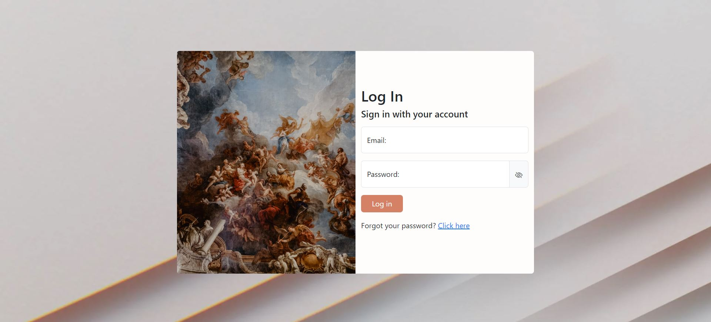

The user will be prompted to log in with their email and password. Note that as a first-time product user, they will have to enter the email and password pre-provided in the database. (Email: [artgallery23@outlook.com](mailto:artgallery23@outlook.com) Password: artgalleryPass)

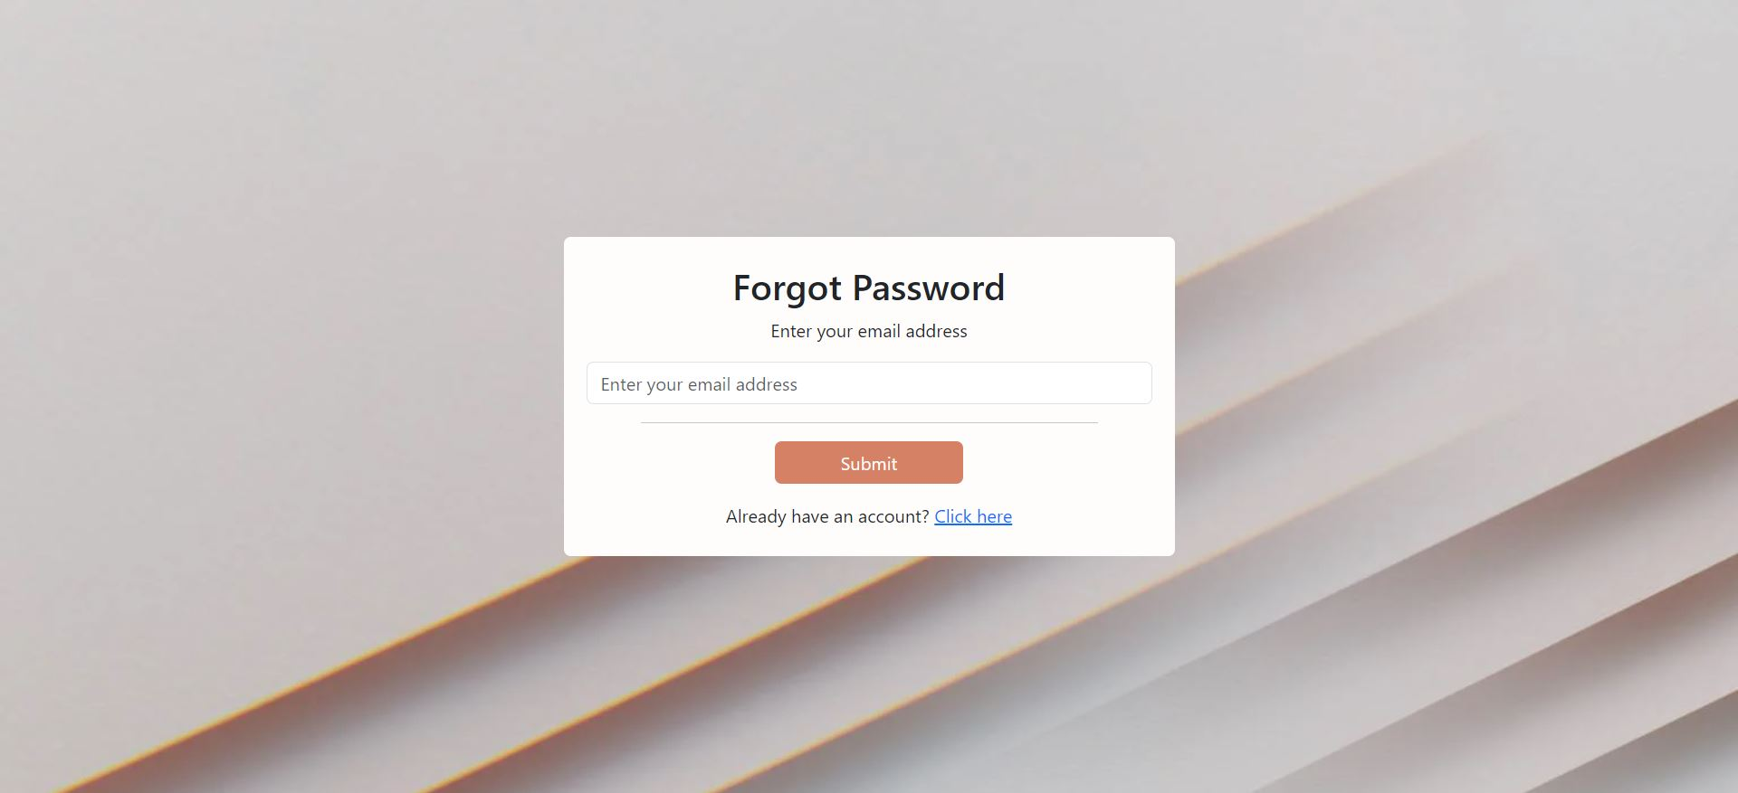The user can click on ‘Click Here’ to be redirected to the ‘Forgot Password’ page where he/she will be asked to enter their email address which they’d usually sign in with.

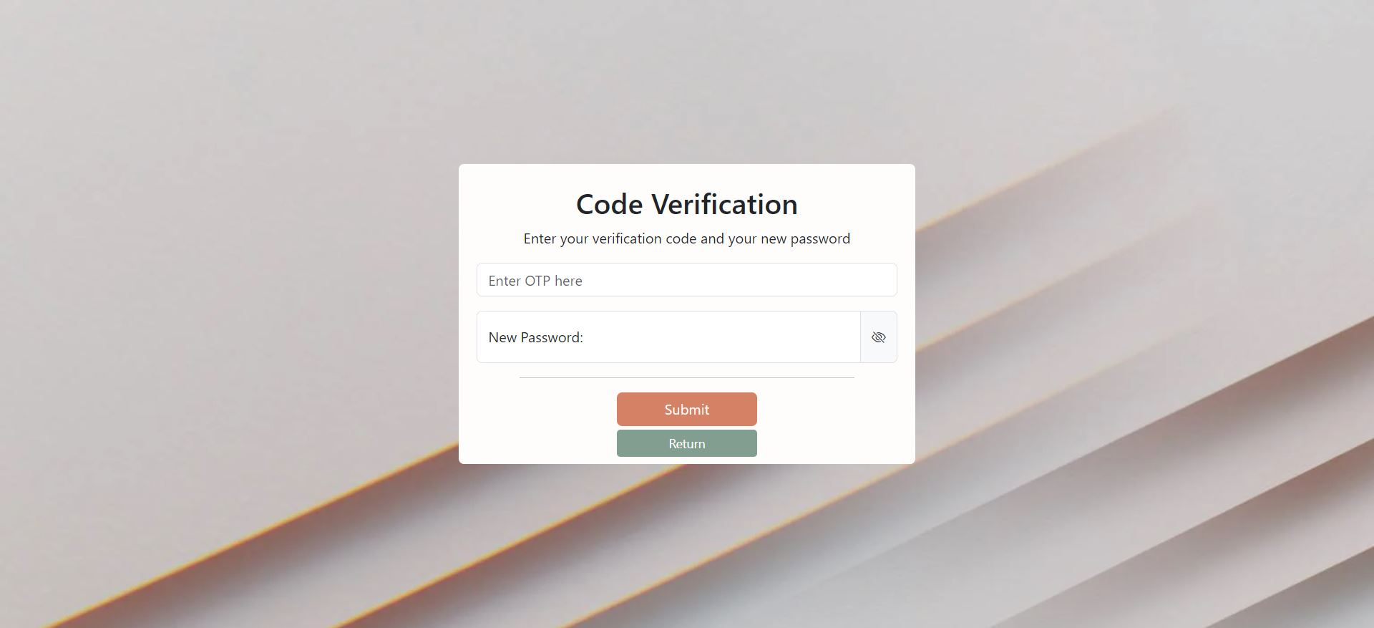The user will then be sent an email with a one-time password to use in order to set a new password for their account. Note that the email may be sent to the spam or trash folder, so make sure to check those, too.



Email sent with the one-time password code

Once a new password is set, the user will be redirected to the login page where the user will be able to log in and taken to the home page.

1. Landing/Home Page

After the user has logged in, he/she will be taken to the landing page where they can navigate to the various tables like the artists, guests, and, with the correct employee role, employees table, too.

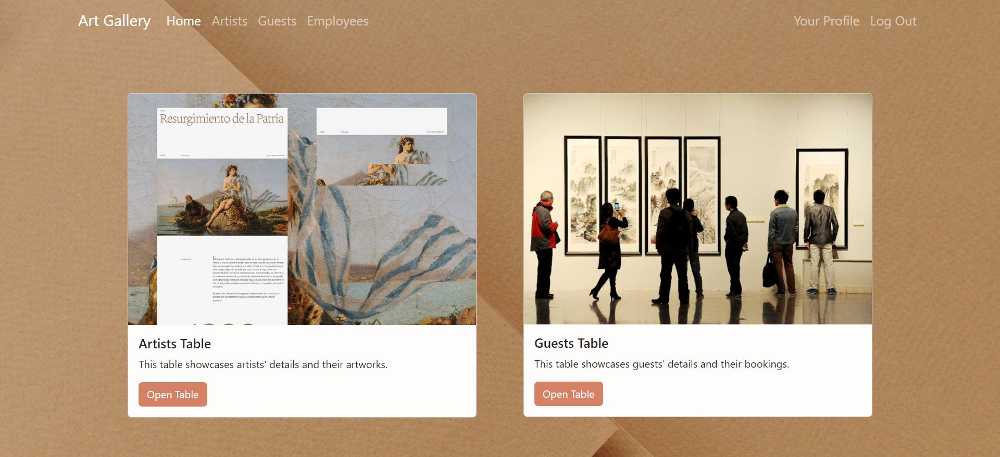Should a user with an inappropriate role try to access the employee’s table, a message will show up notifying them that they cannot access it.

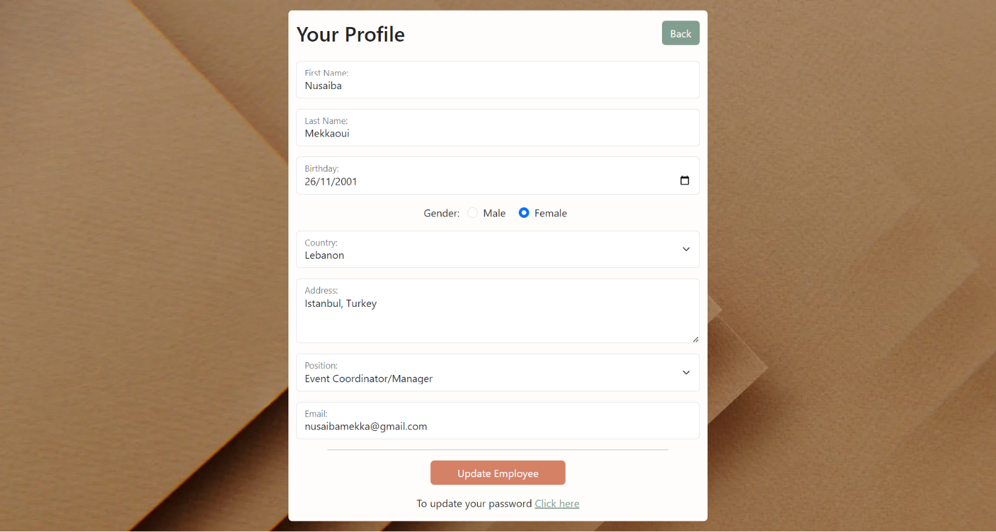The user also has the option to view their own profile information and to update their password out after landing in the home page.

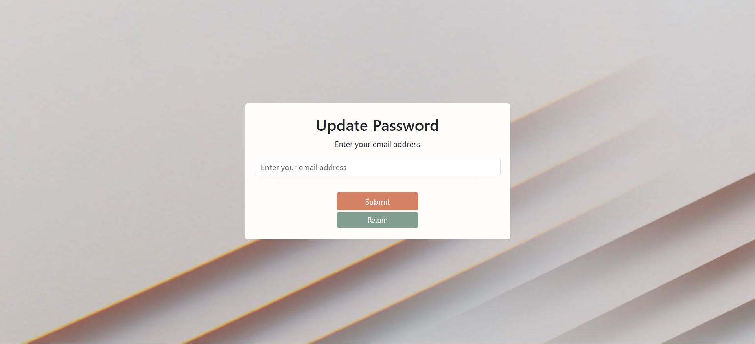Should the user decide to update their password, he/she will be redirected to another page asking the user the enter their email.

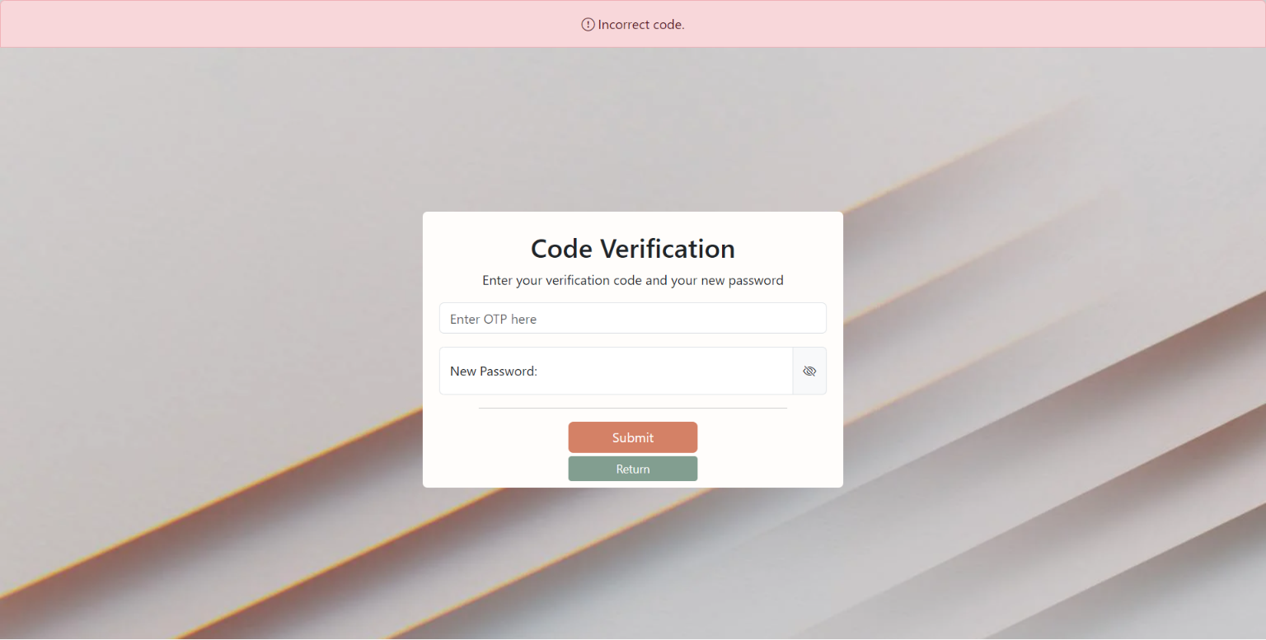Once the user has submitted their email, a code will be sent to the user’s email where he/she will use it to enter a new password. If the user has entered the wrong code, a message will appear notifying them of the error.

Updating the user’s password will display a message of the change being made successfully.

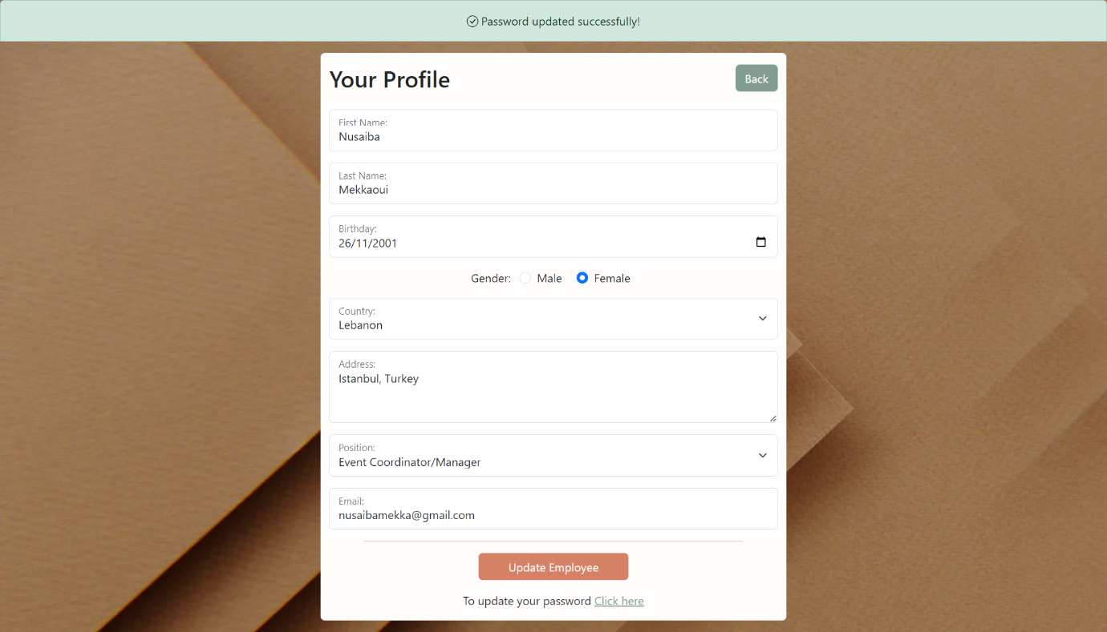

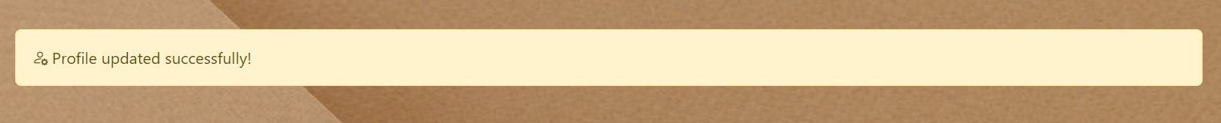Updating the user information on the other hand will redirect the user to the landing page where a message will be displayed to inform them of the changes being made successfully.

1. Artist
2. Artist Table

The Artist Table displays all the artist information present in the database. The information includes the artists’ first names, surnames, emails, dates of their shows, number of art pieces, and the art style they’ll be displaying at the gallery.

Also, from this page, the user can then view or update the information of a certain artist, or delete a specific artist using the following three buttons, respectively.

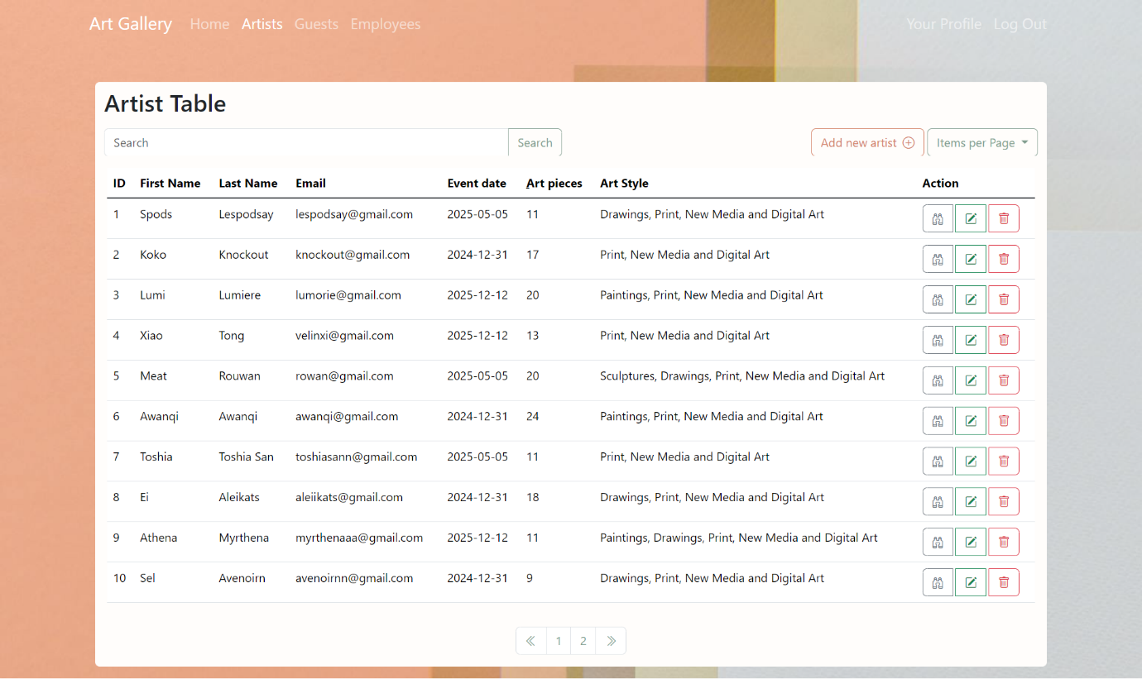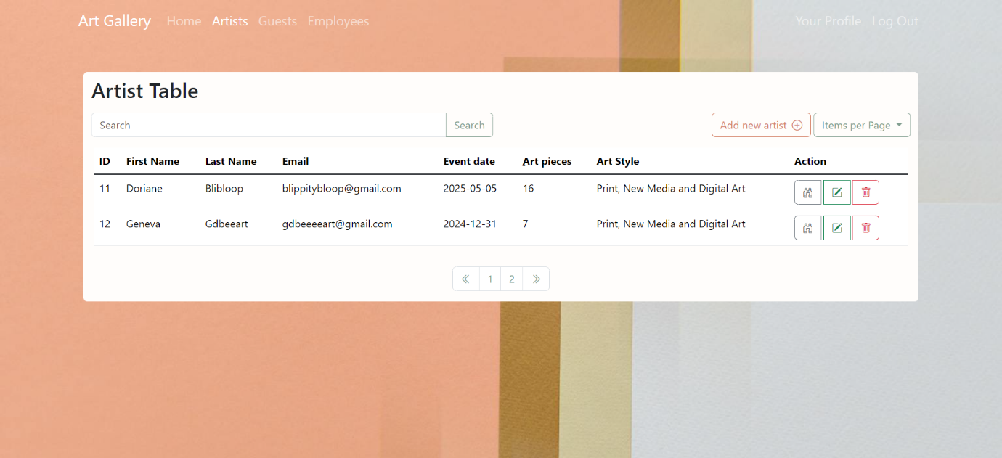

Additionally, the user can choose to view 10, 30 or 50 entries in a page by selecting one of the options in the ‘Items per Page’ drop down menu. The user can go to the next page to view the rest of the entries using the buttons present at the bottom of the table.

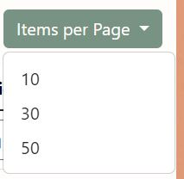



1. Add New Artist

By clicking on the ‘Add New Artist’ button at the top of the artist table, the user will be redirected to a new page where the user able to add a new artist to the database via a form. A message will be displayed upon clicking the ‘Add Artist’ button.

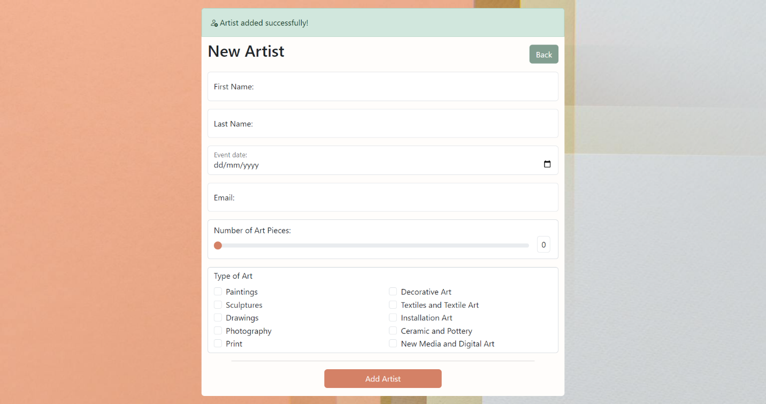

1. View Artist

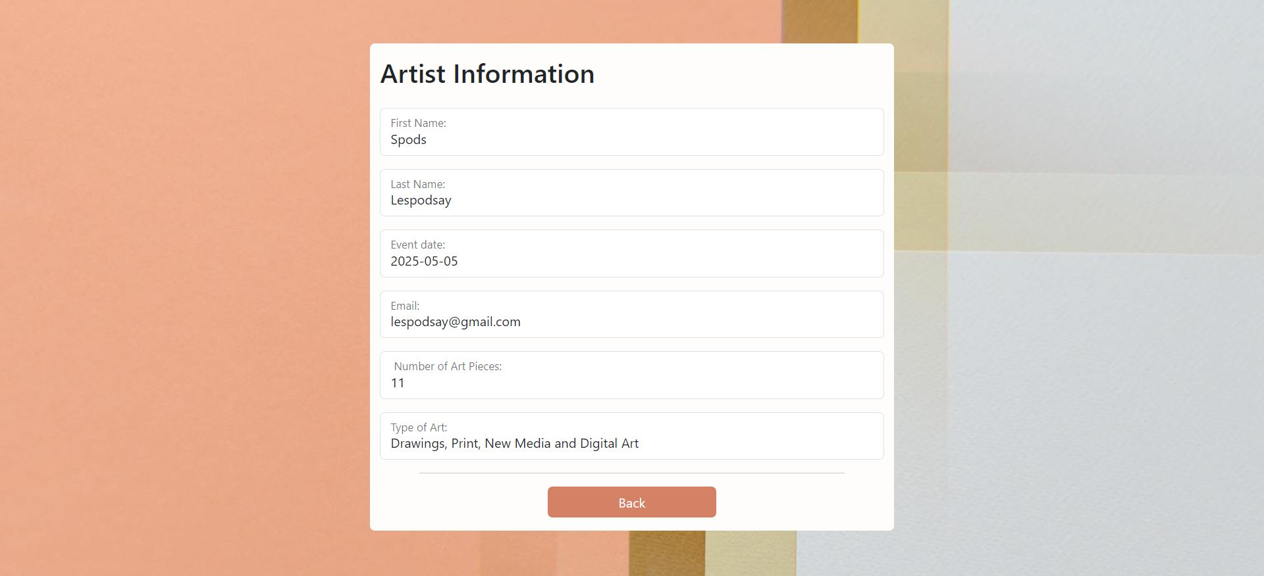By clicking on the binoculars button on the Artist Table page, the user will be able to view a select artist’s information, unable to change any of the fields, and then go back to the artist table using the back button.

1. Update Artist

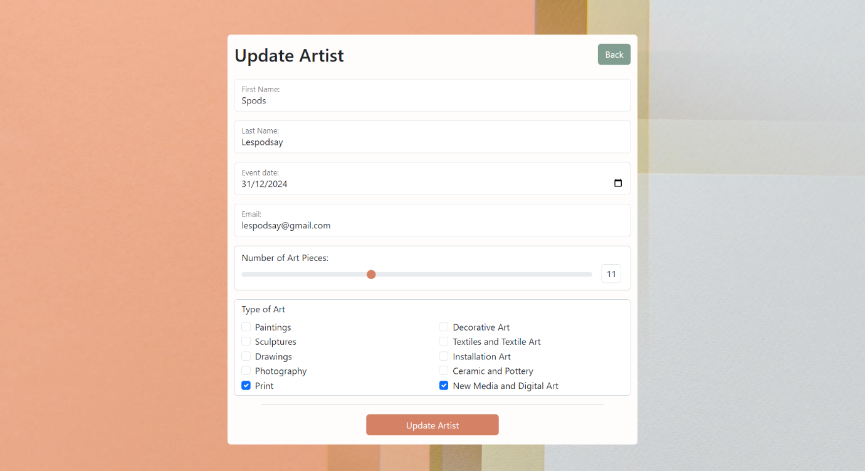Upon clicking the edit button on the Artist Table page, the user will be redirected towards an update form where the existing information of the artist will be available for the user to modify. From there, the user can choose to go back to the Artist Table, too.

Once the user clicks ‘Update Artist’, the data in the Artist Table, both in the browser and the database, will be updated.



After Date of Show and Art Styles have been updated.



Before Date of Show and Art Styles have been updated.

Updating the artist will result in a message being displayed at the top of the artist table.



1. Delete Artist

Upon clicking the trashcan button on the Artist Table page, a pop-up alert will be displayed on the Artist Table Page asking the user to confirm whether they want the specific record to be permanently deleted or not.

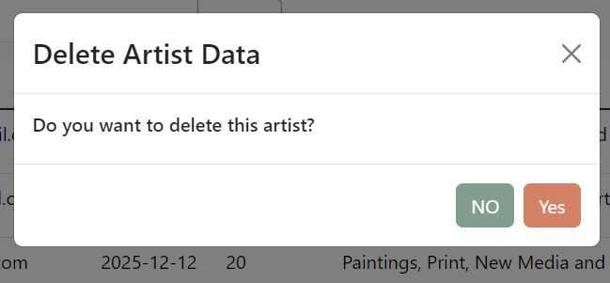

If the user chooses to click ‘Yes’ the record will be permanently removed from the table and a message informing the user of the successful deletion will be displayed, as seen below.

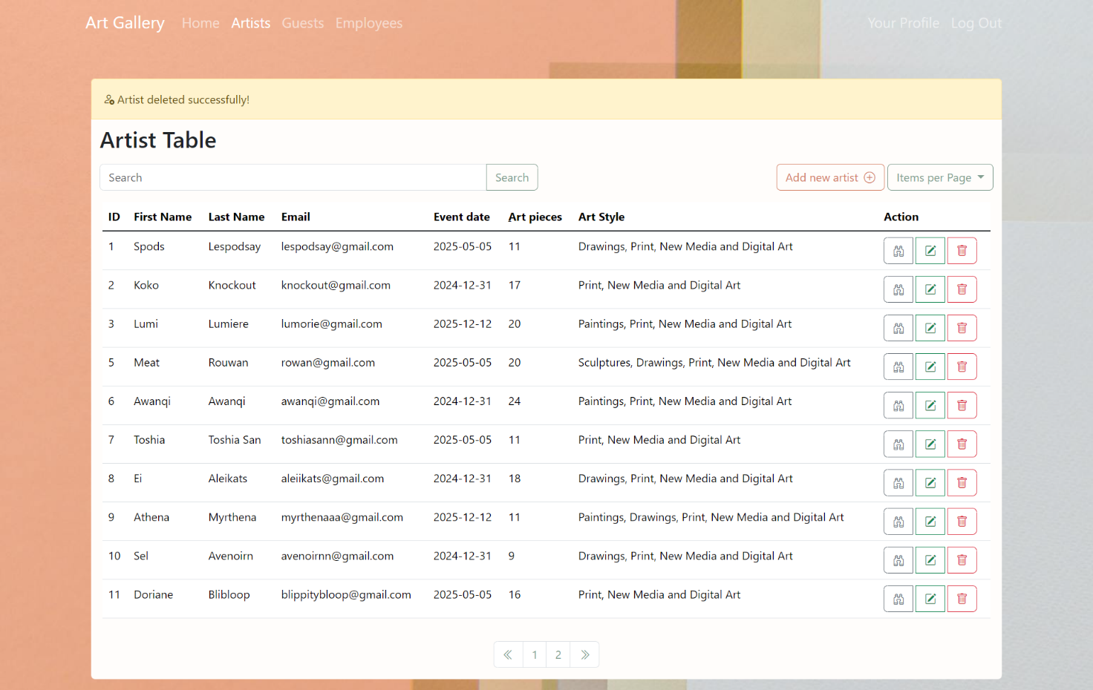

1. Search Artist

The user can also search for a specific artist using the search bar at the top of the table.

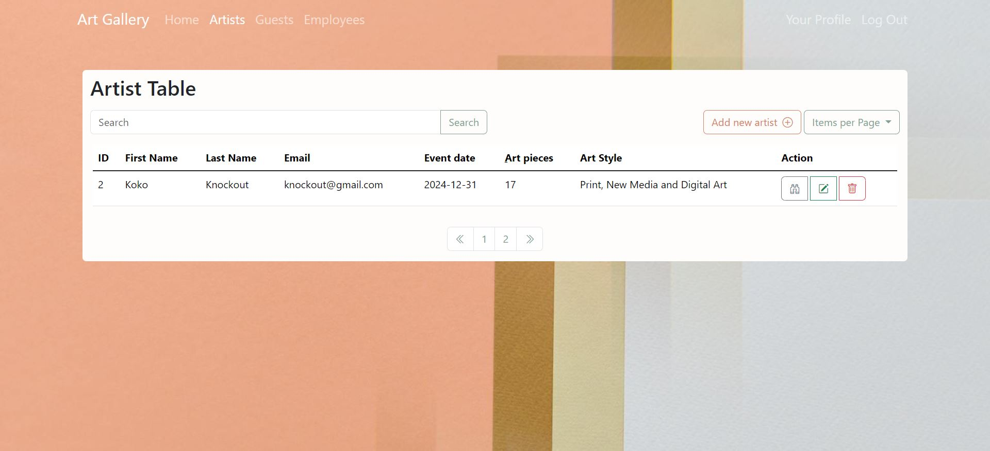Once the information is entered in to the search bar and the user hits search, only the relevant entries will be shown in the table. From there, the user can click the search button again to view all of the artist entries in the database.

1. Guest
   1. Guest Table

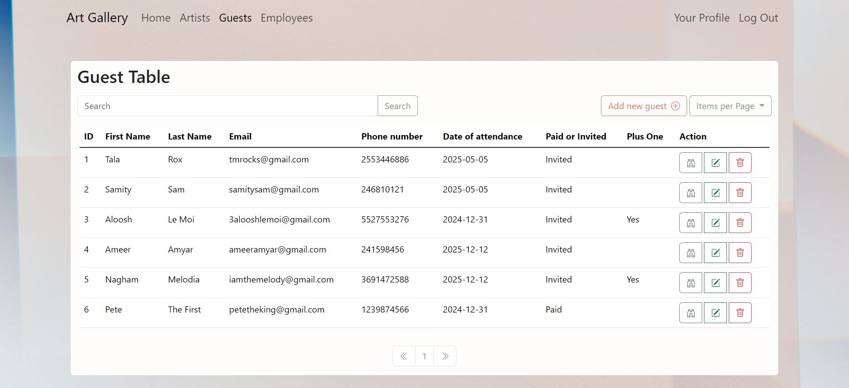The Guest Table displays all the guest information present in the database. The information includes the guests’ first names, surnames, emails, the dates of their attendance, whether they are paid/invited guests, and, if the guest was invited, whether or not he/she have a plus one with them.

Similar to the artist table, the user can then view or update the information of a certain guest, or delete a specific guest.

All the CRUD operations of the guest table are the same as the artist table. A few things to note, however, is the paid/ invited field in the ‘New Guest’ Page. Only invited guests are allowed a Plus One (+1) option as can be seen below:



The Plus One (+1) option is unavailable for paid guests.



The Plus One (+1) option becomes available for invited guests.



1. Employee
2. Employee Table

Granted that the user has a high-ranking role as an employee at the gallery, they’ll be able to access the employee table.

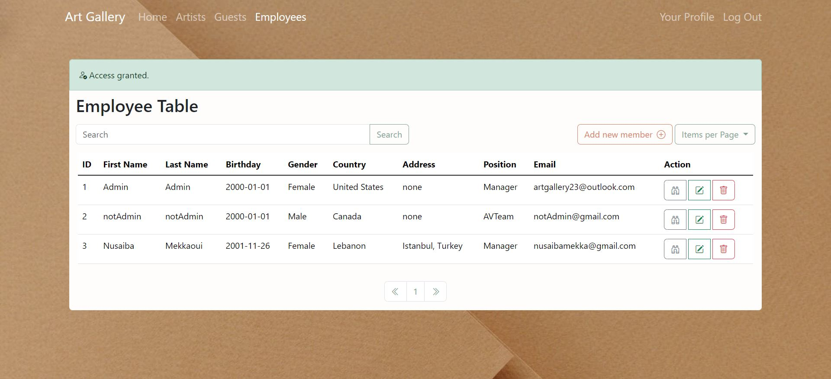The Employee Table displays all the employee information present in the database. The information includes the employee’s first name, surname, birthdate, gender, nationality, address, position and email, and while the password will be shown as an encrypted value in the database, it will not be shown at all in the browser. Just like the artist table, the user will be able to view, update employee information or delete specific employees.

If the user does not have the appropriate role of a manager, the user will be unable to access the employees’ table and a message will be displayed on whichever page that user is on.



Once the user has finished, he/she can log out using the logout button at the top right of any page.

